Assignment 5

War file configured on master and deployed on slave

Configuration

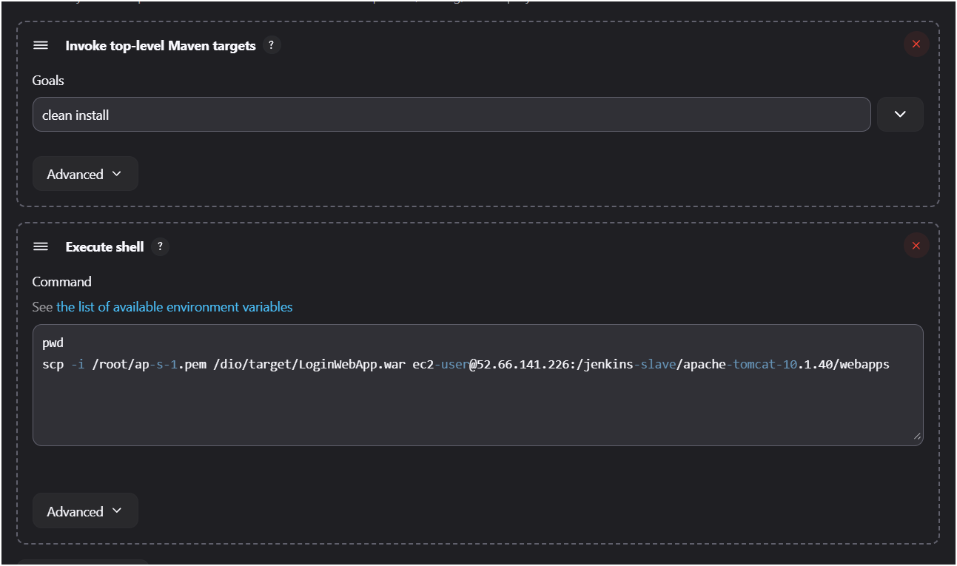

File on slave

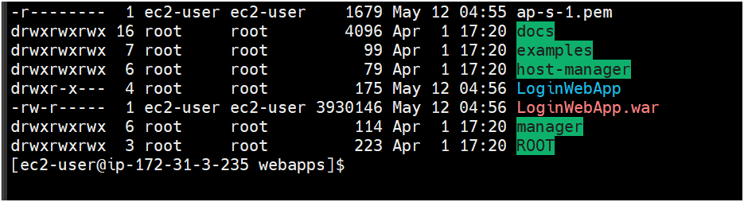

Live webapp

